The front of the shirt will have the logo below and the back of the shirts will have the school’s name with list of all swimmers sent by coaches to Mike via a Hy-Tek Roster by Friday, May 13, 2022 by 12:00 pm.. (owensmi@lc-ps.org and lcnswim@yahoo.com)

The t-shirts will be short sleeve. The t-shirt color will be RED shirts with SHADES OF WHITE imprint. The front of the shirt will have the following logo:
- DESIGN: 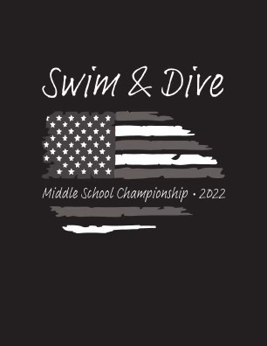
- Shirt order forms are due TUESDAY, May 17, 2022 by 5:00 pm.

Please fill out information below and return with a Hy-Tek Roster. Please send your t-shirt order form to Mike so he can make sure we have the proper split of shirts between the 2 meets. A few extra shirts will be ordered, but not many. Please ask your swimmers to complete the form below so you can keep track of your order. Please submit 1 order form from each team. Payment will be required to receive your Team shirts. Order form slip is due by TUESDAY, May 17, 2022 by 5:00 pm. T-shirts will not be delivered until payment is received. (Don’t forget to ask your parents!)

Team Name _______________________________________________________
Swimmer’s Name _______________________________________________________
7th & 8th Grader’s 6th Graders
Shirt Size: Adult sizes TOTAL Shirt Size: Adult sizes TOTAL
Short Sleeve T-Shirt Short Sleeve T-Shirt
Small Qty_____ x $18.00 = __________ Small Qty_____ x $18.00 = _________
Medium Qty_____ x $18.00 = __________ Medium Qty_____ x $18.00 = _________
Large Qty_____ x $18.00 = __________ Large Qty_____ x $18.00 = _________
X-Large Qty_____ x $18.00 = __________ X-Large Qty_____ x $18.00 = ________
2XL Qty_____ x $20.00 = __________ 2XL Qty_____ x $20.00 = ________
Shirt Size: Youth sizes Shirt Size: Youth sizes
Short Sleeve T-Shirt Short Sleeve T-Shirt
Medium Qty_____ x $18.00 = __________ Medium Qty_____ x $18.00 = _________
Large Qty_____ x $18.00 = __________ Large Qty_____ x $18.00 = _________
Total for order =__________
Grand Total = $ _________
Please make check or money order Payable to:
LCN Swim Team or Pay cash Thank you.

